**UCLA Document**

**XID**

X00202628

**NAME**

Vlad Pocris

**PROJECT TITLE**

RenCloud

**Use Cases and Logical Architecture**

**Section 1: Each Use Case:**

**Legend.**

**Segment –** a part of the video, e.g. on import initially there is 1 segment a.k.a. the full video length imported. When a split is done would result in 2 segments with different length depending on where the split has been made.

**VLC –** library for playing media files.

**FFMPEG –** library for processing video fragments & render.

|  |  |
| --- | --- |
| Title (goal) | Login/Register/Restore Password |
| Primary Actor | User |
| Story | The user wants to login either register or restore password. |

|  |  |
| --- | --- |
| Title (goal) | Skip Login |
| Primary Actor | User |
| Story | The user wants to skip the login and/or registration to start using the application with limited features. |

|  |  |
| --- | --- |
| Title (goal) | Import video to timeline |
| Primary Actor | User |
| Story | After choosing what video/media file the user wants to edit, to begin the editing process he must import the file/files, so it appears on the timeline (showing thumbnails at different timestamps and show audio amplitude bars for better interpretation of higher/lower notes). |

|  |  |
| --- | --- |
| Title (goal) | Select the **segment**. |
| Primary Actor | User |
| Story | The user wants to delete/reposition a specific length of the video. In order to make changes the user would have to select what segment does he want’s to split/delete/move. |

|  |  |
| --- | --- |
| Title (goal) | Split video/audio. |
| Primary Actor | User |
| Story | The user wants to delete/reposition a specific length of the video (e.g. a video with 1 minute length has been imported, and the user wants to place the last 10 seconds of the clip at the start of the clip or, the user wants to delete the part from 15 - 35 seconds, the user would have to select that length first, which will require to divide the clip into more parts/applies for audio track the same way). In order to do so, as a prerequisite the user would have to select the segment to apply the operation on. |

|  |  |
| --- | --- |
| Title (goal) | Remove video/audio. |
| Primary Actor | User |
| Story | The user wants to delete a specific length of the video. A selected segment would be removed from the timeline. (e.g. a video with 1 minute length has been imported, and the user wants to remove the last 10 seconds of the video, it would result from 2 segments, in 1 segment with length of 50 seconds excluding the last 10 seconds of the video). |

|  |  |
| --- | --- |
| Title (goal) | Move video/audio. |
| Primary Actor | User |
| Story | The user wants to move a specific length of the video at start/end or any position on the timeline. A selected segment would be moved with use of drag-&-drop functionality. (e.g. a video with 1 minute length has been imported, and the user wants to move the last 10 seconds of the video at the start, it would result from 2 segments after the split, in segment nr. 2 with length of 10 seconds and segment nr. 1 with 50 seconds length). |

|  |  |
| --- | --- |
| Title (goal) | Preview the video based on time-line structure |
| Primary Actor | User |
| Story | The user wants to see the changes he/she made to the clip, providing with a fast preview before processing the changes into a final media file based on all split/remove/move operations made. |

|  |  |
| --- | --- |
| Title (goal) | Play preview. |
| Primary Actor | User |
| Story | The user wants to see the changes he/she made to the clip, based on where the timestamp pointer is, the VLC media-player would play the clip from that timestamp. |

|  |  |
| --- | --- |
| Title (goal) | Pause preview. |
| Primary Actor | User |
| Story | The user wants to pause the preview. Based on where the timestamp pointer is, the VLC-media player would stop the clip at that timestamp. |

|  |  |
| --- | --- |
| Title (goal) | Scroll through timeline. |
| Primary Actor | User |
| Story | The user wants to find a certain moment from the video/audio (e.g. the part the user wants to remove or apply operations on).  Using the VLC-media player, it would update its timestamp based on where the timestamp pointer is dragged, providing user with fast glance of media file. The media player would update its thumbnail each millisecond when scrolling. |

|  |  |
| --- | --- |
| Title (goal) | Specify preview settings |
| Primary Actor | User |
| Story | The user wants to set specific preview settings in order to visualize the timeline, user would be able to set those and choose the right settings based on their hardware compatibilities, better settings results in more hardware resource usage, less settings results in less hardware resource usage, this directly impact how fast the preview is generated after certain changes so it directly depends on hardware the machine holds, therefore providing user with a way to select the best settings for comfortable use. |

|  |  |
| --- | --- |
| Title (goal) | Render the output |
| Primary Actor | User |
| Story | The user wants to export the final product, a tab would allow the user to specify render settings such as: fps (frames per second); width/height of the video; acceleration type based on what video graphics card the user hold if there are any suitable; maximum amount of CPU usage; location to export the file. |

|  |  |
| --- | --- |
| Title (goal) | Use buttons instead of short keys |
| Primary Actor | User |
| Story | The user wants to use buttons instead of short keys, a tooltip will be available named Control Panel, that will open a form allowing the user to use buttons instead. |

|  |  |
| --- | --- |
| Title (goal) | Help |
| Primary Actor | User |
| Story | The user wants to understand how to use the app, the help panel will show the user different examples of the app functionality such as: short keys; how to open the panel; operations available; etc. |

|  |  |
| --- | --- |
| Title (goal) | Save the project for future use |
| Primary Actor | User |
| Story | The user wants to save the current project so he can continue later, the user will have the option to “save project as” that will save necessary data. |
| Title (goal) | Open existing project |
| Primary Actor | User |
| Story | The user wants to open a saved project to continue, the user would have to open the project file that will be imported into the application. |

**UNPLANNED IMPLEMENTED FEATURES**

**(No flow representation for these feature due to lack of time.)**

|  |  |
| --- | --- |
| Title (goal) | Mute video track |
| Primary Actor | User |
| Story | The user wants to focus more on editing audio rather video, the user would have to check a checkbox and the preview will only play audio. |

|  |  |
| --- | --- |
| Title (goal) | Mute audio track |
| Primary Actor | User |
| Story | The user wants to focus more on editing video rather audio, the user would have to check a checkbox and the preview will only play the video. |

|  |  |
| --- | --- |
| Title (goal) | Fast Preview Generation |
| Primary Actor | User |
| Story | The user works with big files e.g. 4k/2k that takes lots of time to process each change, the user would have to hit a checkbox to enable this feature which will drastically speed the processing, however at cost of need for resync once 10-15 times at the user choice. (the ffmpeg math behind trimming would desynchronise the actual final output since the generated preview from original clips would be reused and would have to be updated once a while.) |

|  |  |
| --- | --- |
| Title (goal) | Templates |
| Primary Actor | User |
| Story | The user is not advanced and doesn’t really know the settings behind the processing, he could chose specific template for predefined platforms e.g. High-Quality Youtube and so on. |

|  |  |
| --- | --- |
| Title (goal) | Fast Settings |
| Primary Actor | User |
| Story | The user is somewhat advanced and would want to create a custom mix of settings e.g. FPS: High quality; Resolution: Mid quality and so on. While still having the profit of templates. |

|  |  |
| --- | --- |
| Title (goal) | Advanced Settings |
| Primary Actor | User |
| Story | The user is advanced in video editing and want full control over the settings, he would have to tick a checkbox that gives the user a warning to be cautious since it is meant for professionals only, when checked all fields become available and fast settings are disabled, while having access to profit from templates also! |

|  |  |
| --- | --- |
| Title (goal) | Save Custom Templates |
| Primary Actor | User |
| Story | The user picked it’s own mix of settings and want to save for future use, he would have to just click a button to save the template, and would have to confirm the name giving flexibility to even overwrite if there is any already there with the same name, working both for fast & advanced settings. |

|  |  |
| --- | --- |
| Title (goal) | Delete Custom Templates |
| Primary Actor | User |
| Story | The user wants to remove some unused templates, he would just have to pick the one from combo box and hit delete button. |

|  |  |
| --- | --- |
| Title (goal) | Import metadata |
| Primary Actor | User |
| Story | The user wants to just import some media for future use, by using the tool tip he would click import media option that would let the user to select the media file and it will be displayed only as a thumbnail and name. |

|  |  |
| --- | --- |
| Title (goal) | Add Imported Media |
| Primary Actor | User |
| Story | The user wants to make use of pre-imported media metadata by adding it to the timeline to proceed with editing, it has drag-&-drop functionality, that lets the user to drag and just drop on the timeline the component. |

**Section 2: Logical Architecture**

**LOGIN/REGISTER/RESTORE PASSWORD – CLOUD NOT IMPLEMENTED**

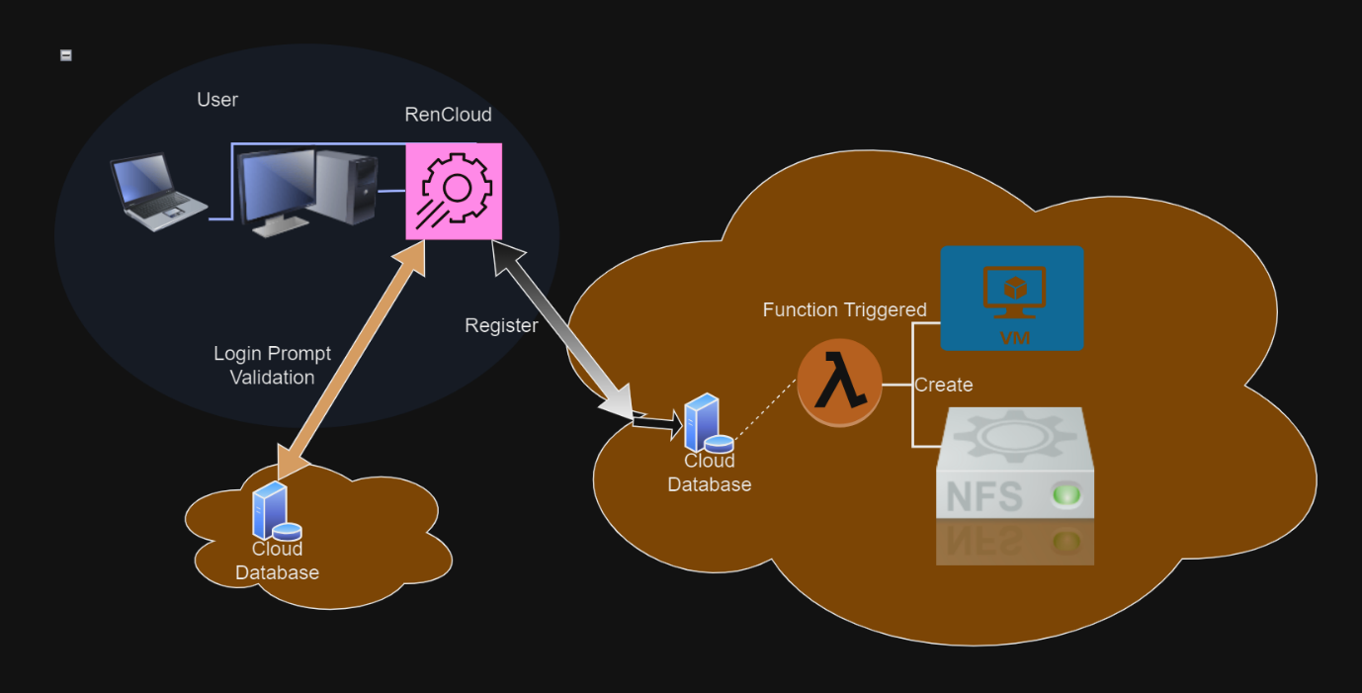

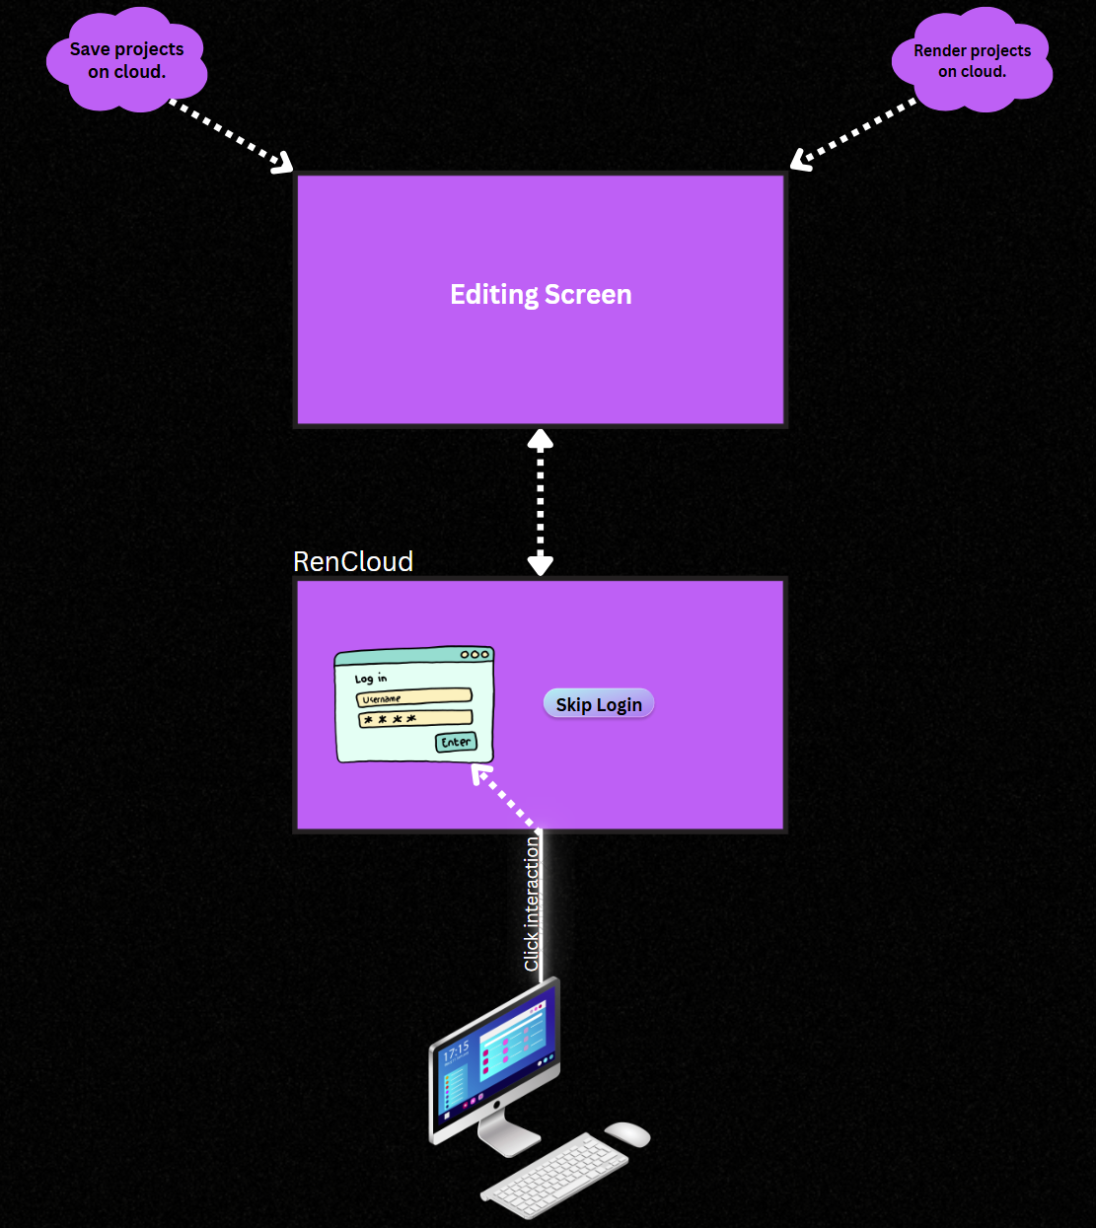

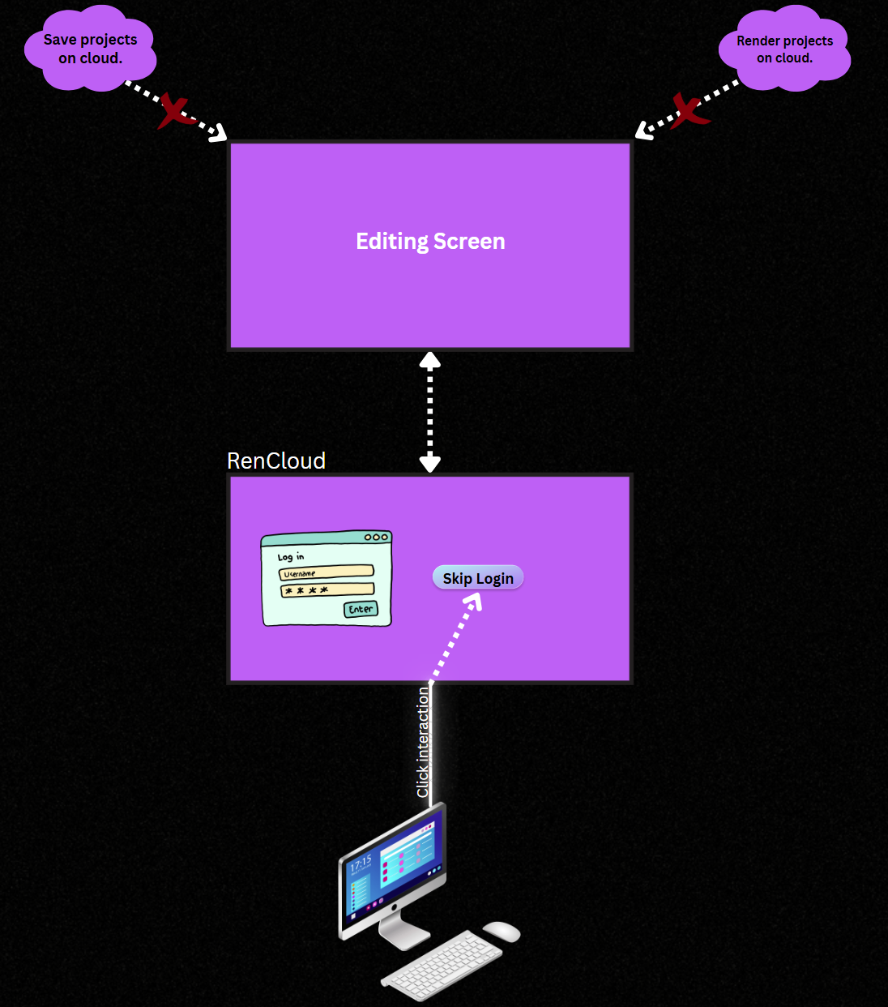

**SKIP LOGIN – CLOUD NOT IMPLEMENTED**

**IMPORT VIDEO TO TIMELINE**

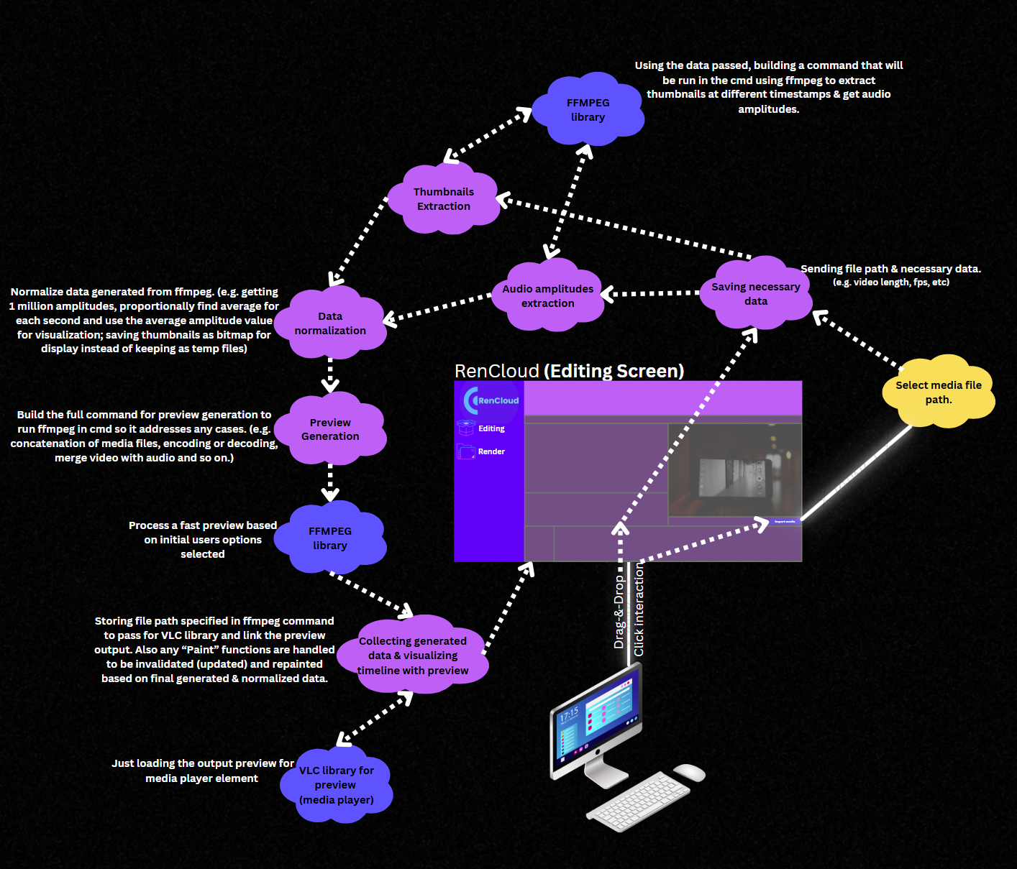

*(if interested in data structure stored for future use, please contact me)*

**SELECT SEGMENT**

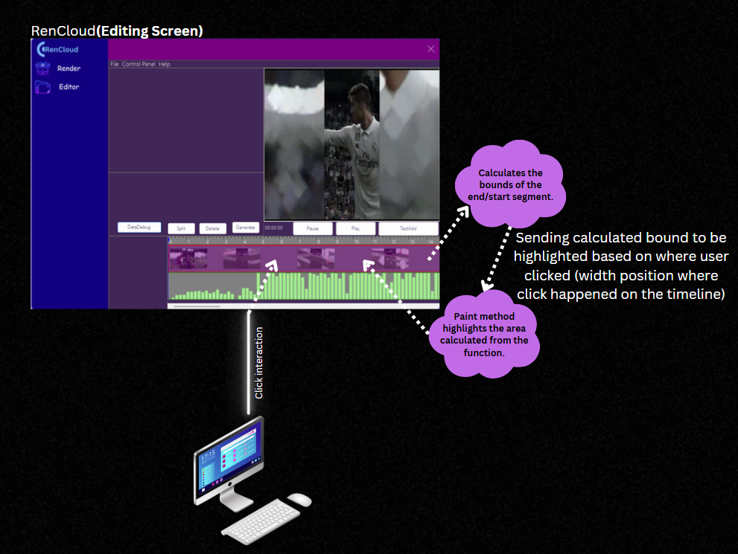

**SPLIT VIDEO/AUDIO**

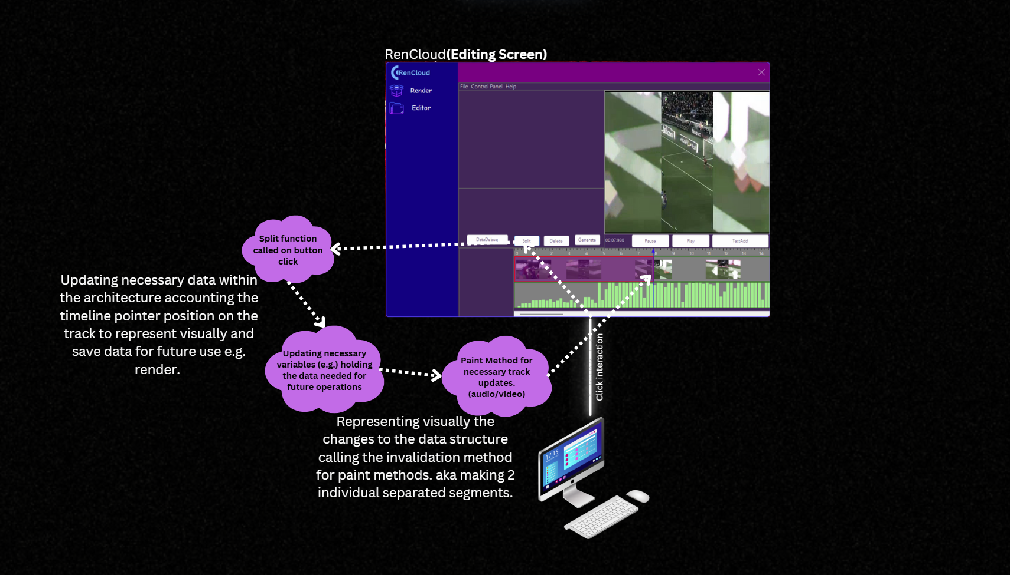

**REMOVE VIDEO/AUDIO SEGMENT**

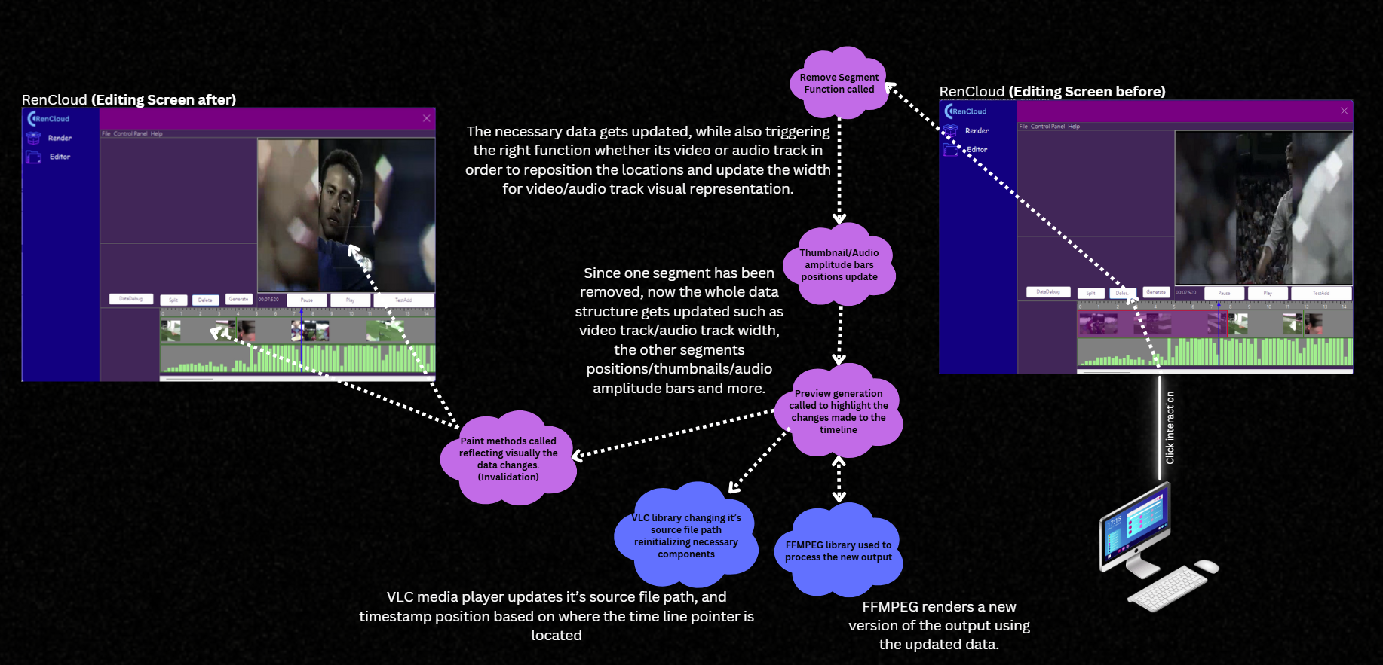

**MOVE AUDIO/VIDEO SEGMENT**

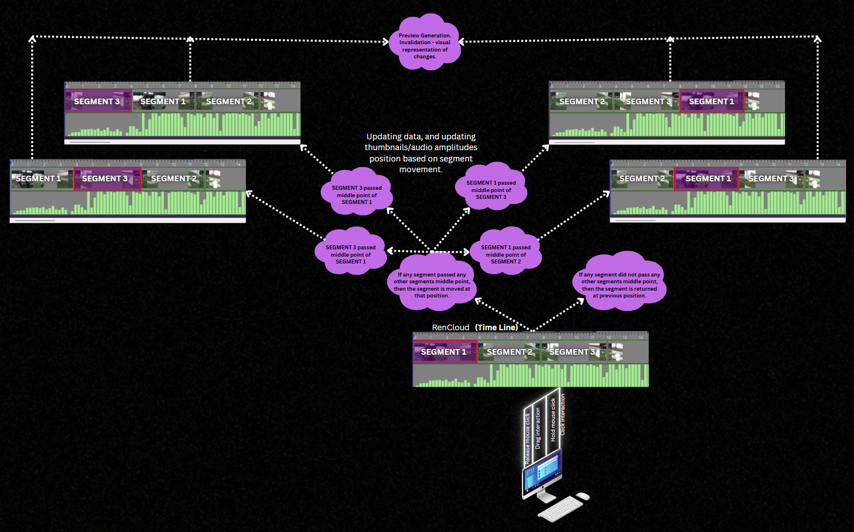

**PREVIEW THE VIDEO BASED ON TIME-LINE STRUCTURE**

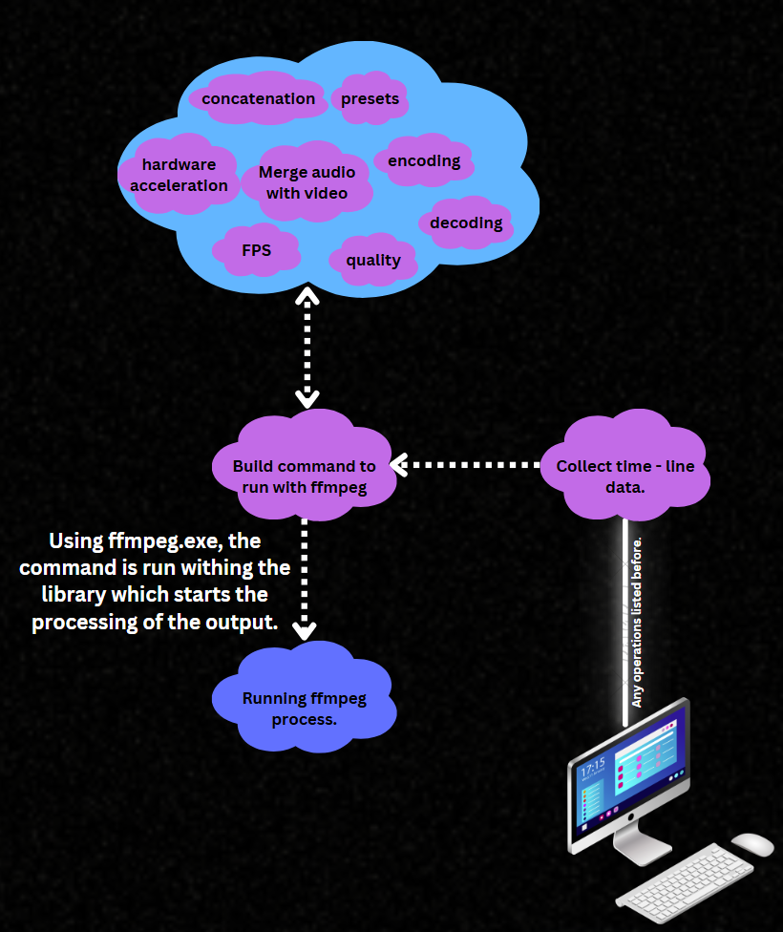

**PLAY PREVIEW**

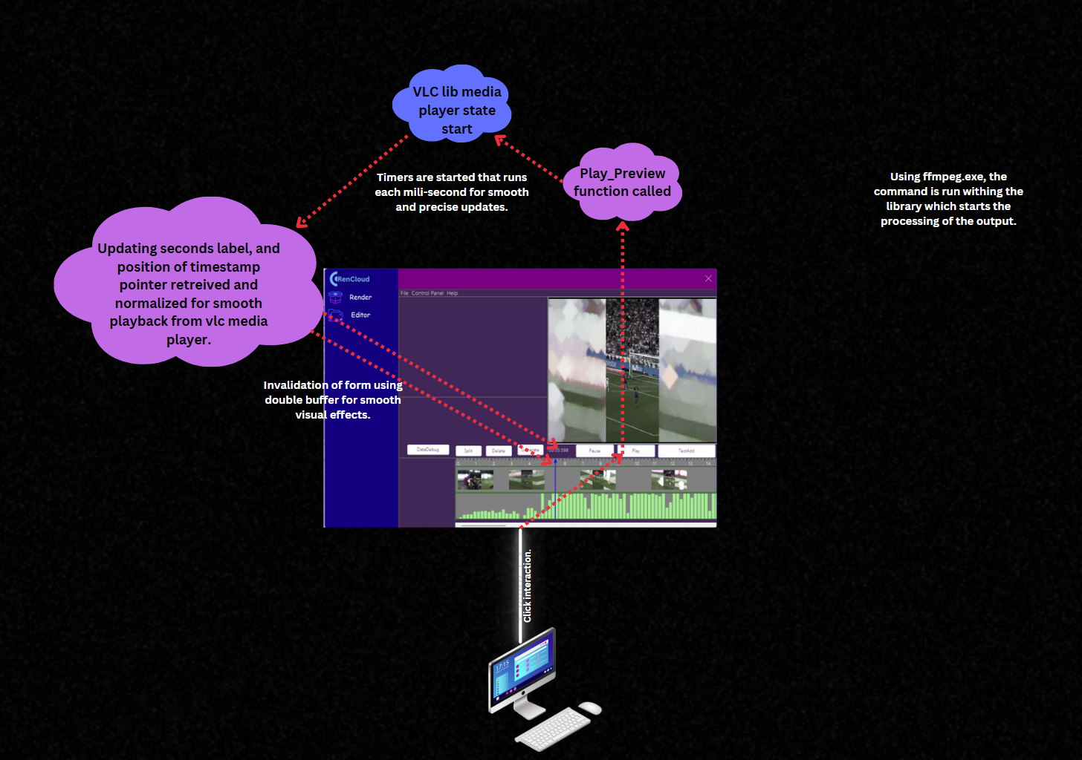

**PAUSE PREVIEW**

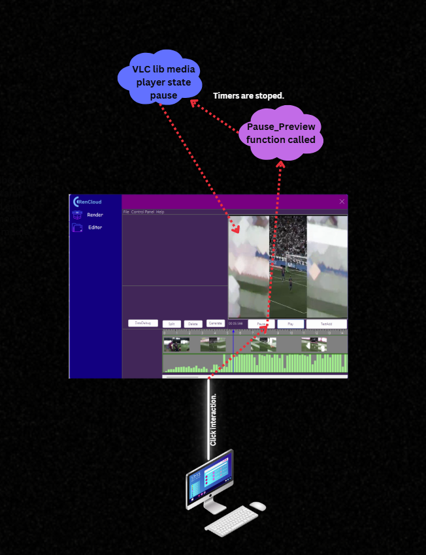

**SCROLL THROUGH TIMELINE**

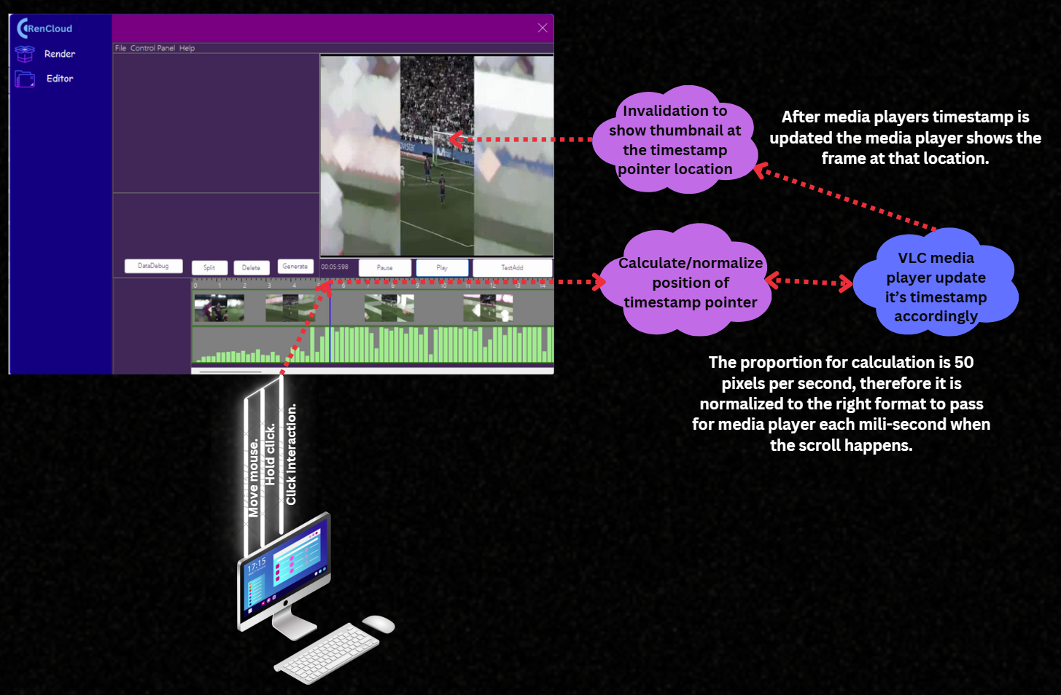

**SPECIFY PREVIEW SETTINGS**

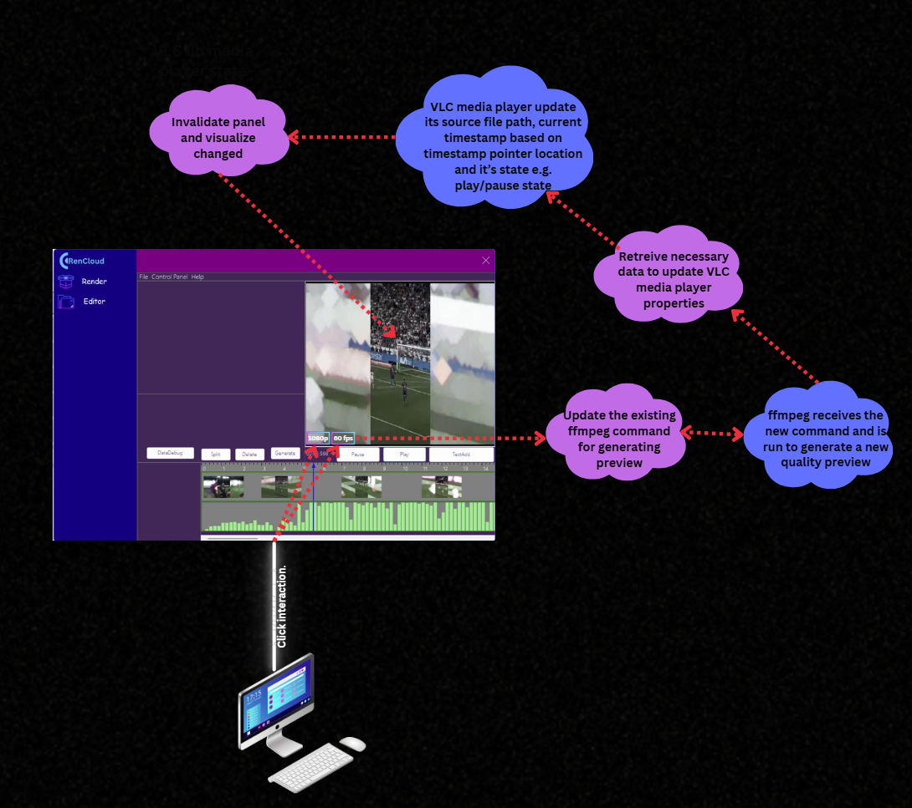

**RENDER THE OUTPUT**

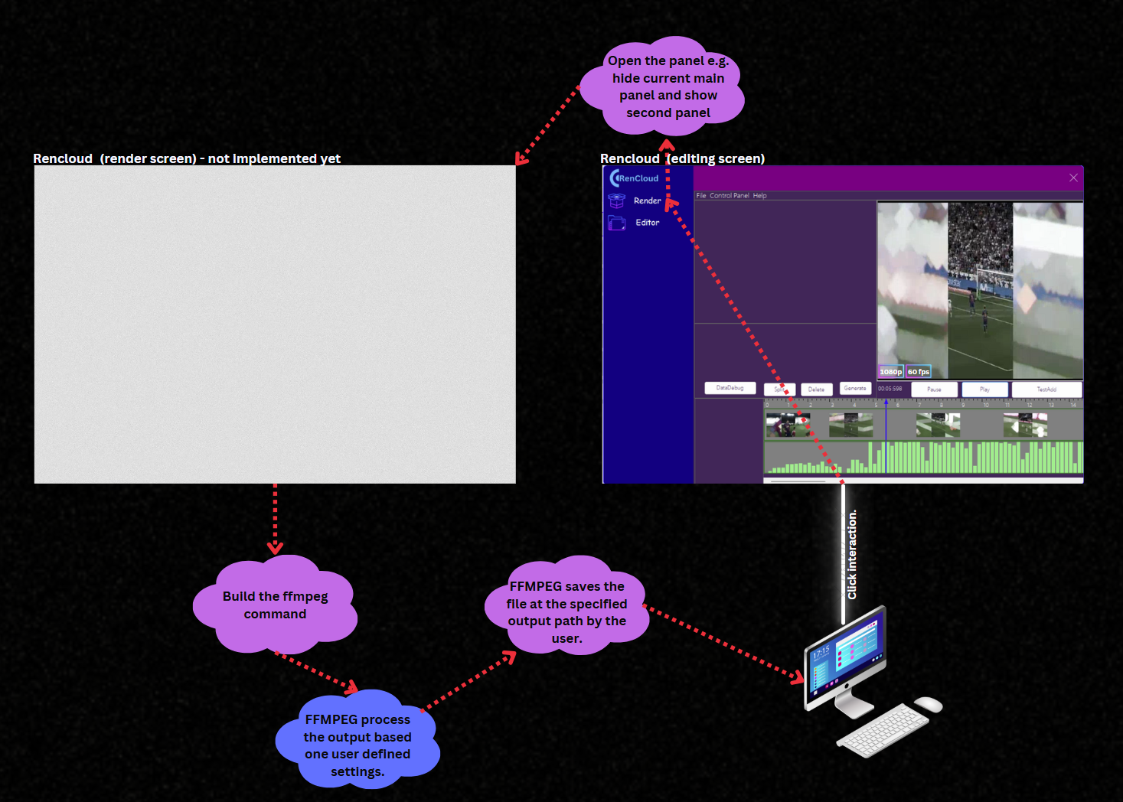

**USE BUTTONS INSTEAD OF SHORTKEYS**

**STORY: The buttons are there at the moment as for testing purposes but it won’t be available when short key functionality would replace them as default.**

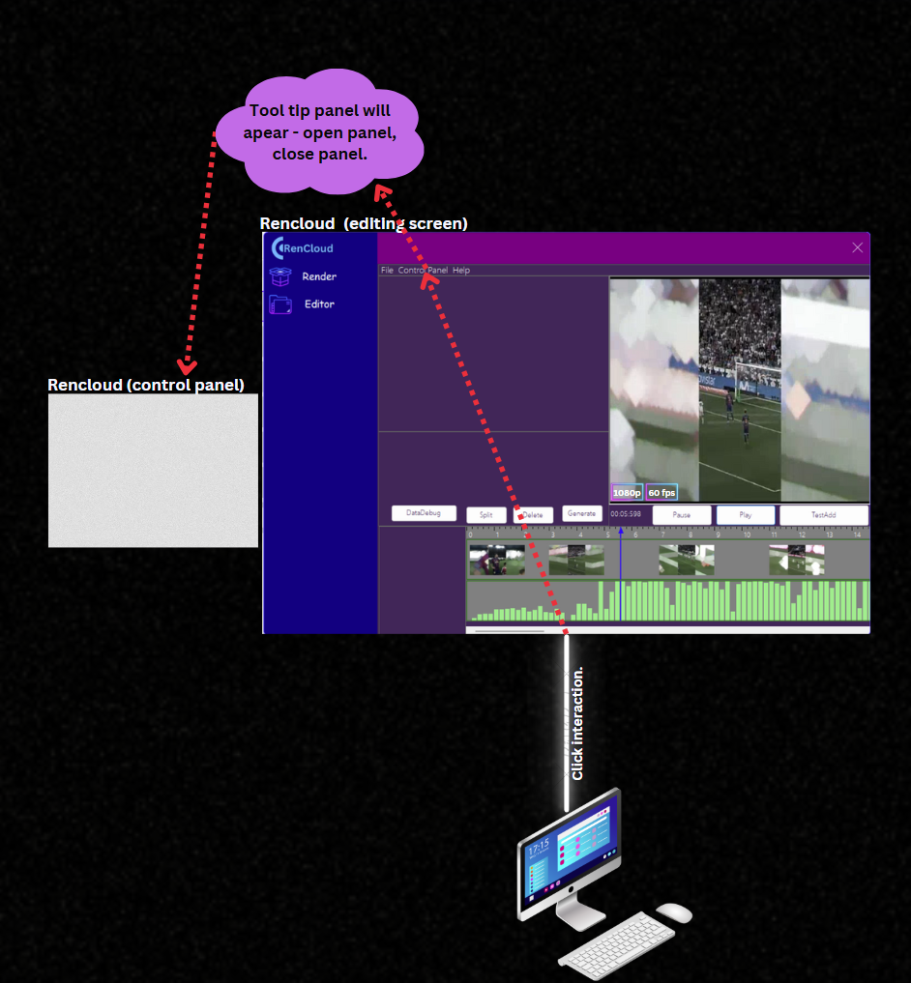

**HELP**

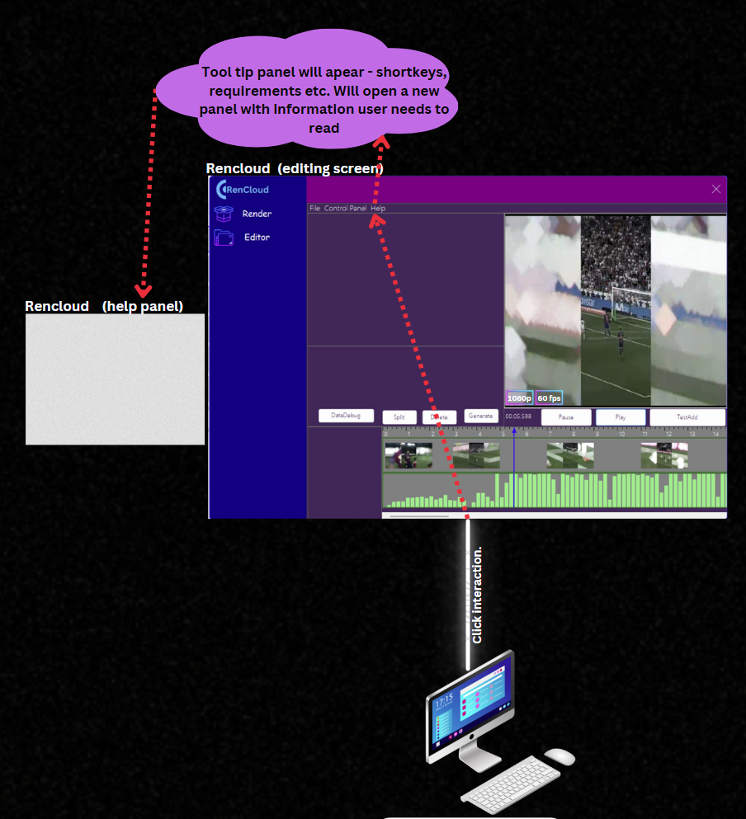

**SAVE THE PROJECT FOR FUTURE USE**

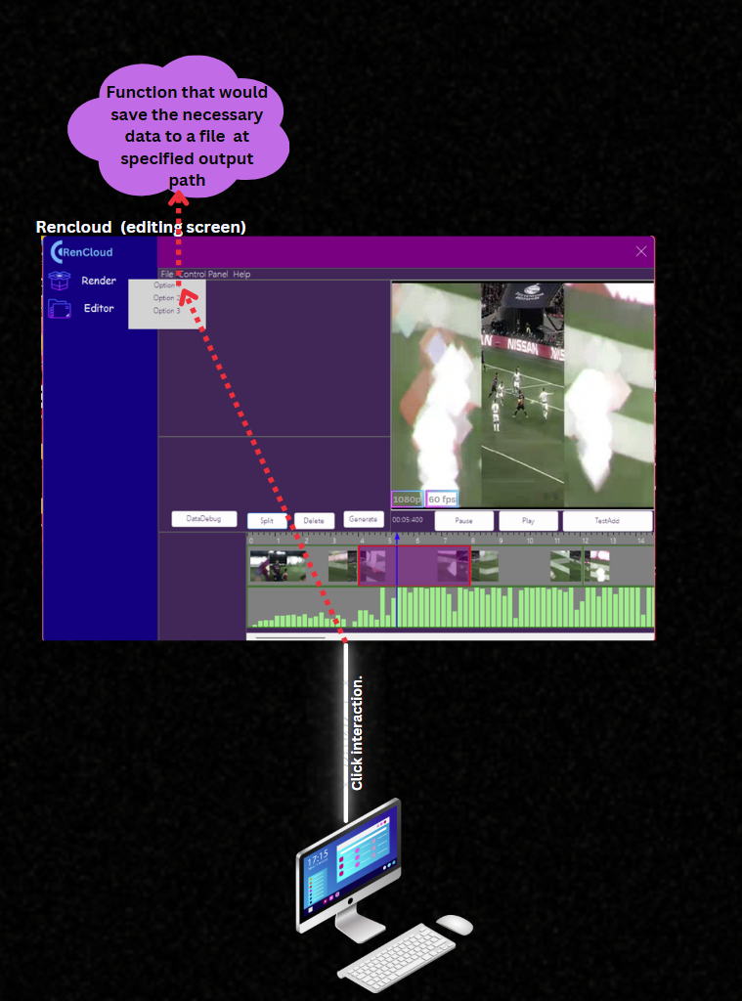

**OPEN EXISTING PROJECT**

